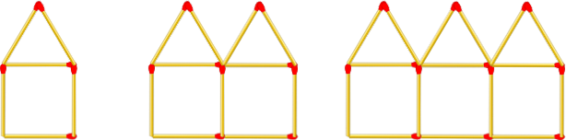

Create a function that takes a number (step) as an argument and returns the number of matchsticks in that step. See step 1, 2 and 3 in the image above.

import java.util.ArrayList;

import java.util.Arrays;

import java.util.regex.Matcher;

import java.util.regex.Pattern;

public class Main

{

public static int togetmatchsticks(int n)

{

int total = 0;

if(n > 1)

{

int neven = n / 2;

/\*

total = (6 + 6 - 1) \* neven;

for (int i = 0; i < neven; i++) {

total = (6 + 6 - 1) \* neven;

}

\*/

total = n \* (6)- (n-1);

}

else {

total= 6;

}

return total;

}

public static void main(String[] args)

{

System.out.println(togetmatchsticks(1));;

System.out.println(togetmatchsticks(4));;

System.out.println(togetmatchsticks(87));;

}

}